**Power Bi Assignment 2**

**( Name = khushal tondon)**

**Ans 1**

Guided NLQ is a unique self-service BI experience

[NLQ](https://www.yellowfinbi.com/campaign/guided-nlq) provides immediate assistance on the question you want to ask, with no guesswork or technical knowledge required to get started with using the tool.

After selecting a dataset, you’re presented with a search box you can type in, but it’s not blank. Guided NLQ provides a list of options for possible questions, then guides you through each step in formulating the query. You can choose your own path through the question by typing what you want to ask, using your mouse to choose an option, or both.

These add-on elements can help build your query, Once your query is built, Guided NLQ presents the ideal level of data you need to uncover the answer, delivered as a [best practice data visualization](https://www.yellowfinbi.com/analytics-best-practice) (chart), which can also be viewed in tabular form.

From here, you can do a number of things:

* You can go back at any time to rearrange the question
* Change your data view to find more answers from other datasets
* Save your question for later
* Add the answer to existing content in Yellowfin, such as Dashboards, Stories, or Presentation

## Guided NLQ makes it simple to ask complex questions

The questions you can ask search-based NLQ tools are often too basic because the vendor has spent all their effort in fixing the language problem, and their approach doesn’t support question complexity in the best way.

Guided NLQ approaches question complexity differently by implementing thousands of comprehensively modelled question types and sequences, which effectively enables anyone to ask questions of their data, and to deliver answers as best practice visualizations or tabular reports for every possible question combination you can think.

**Ans 2**

Power BI Service’s architecture consists of two parts:

* A front end
* A back end

**Front End cluster**

The front end also called the web front-end cluster acts as an intermediary between clients and the back end. The front end services are used for establishing an initial connection and authenticating clients using Azure Active Directory. The Azure Active Directory stores user identities.

Along with this, Azure Traffic Manager is used to direct user requests to the nearest data center after authentication. Once a client/user is authenticated, the **Azure Content Delivery Network (CDN)** distributes static Power BI content/files to users.

[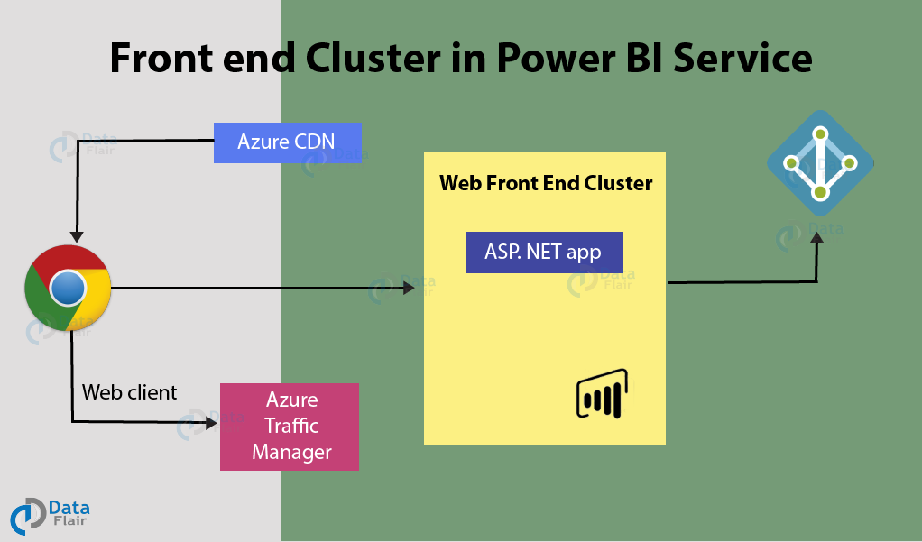](https://data-flair.training/blogs/wp-content/uploads/sites/2/2019/07/Frontend-Cluster-in-PowerBI-architecture.png)

**Ans 4**

The Power BI services at the back end take care of*visualizations, datasets, storage, reports, data connections, data refreshing, and other interactions* with Power BI. At the back-end, a web client has only two direct points of interaction, **Azure API Management**, and **Gateway Role**. These two components are responsible for *load balancing, authentication, authorization, routing,* etc.

[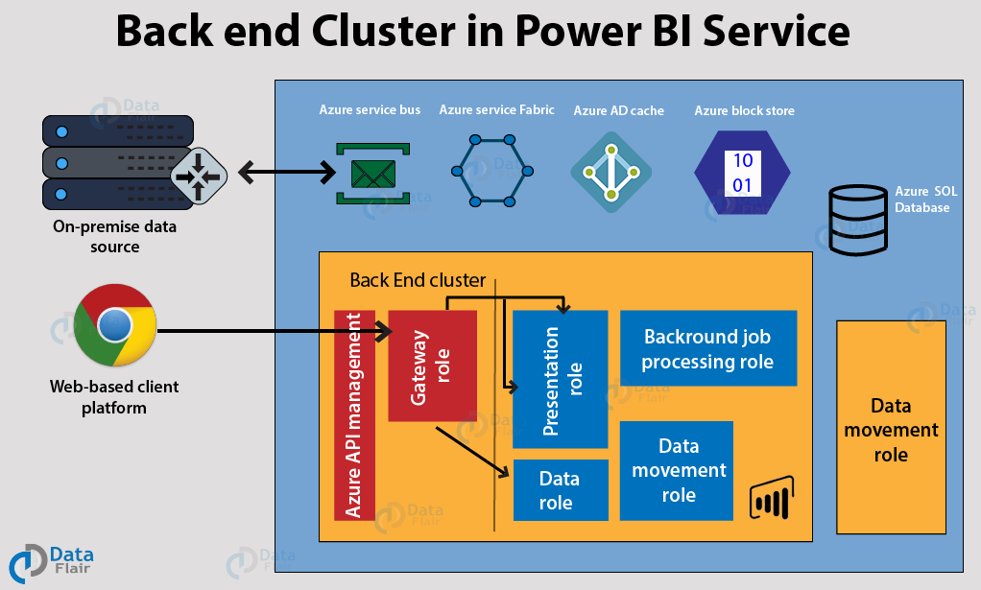](https://data-flair.training/blogs/wp-content/uploads/sites/2/2019/07/Backend-Cluster-in-PowerBI-architecture.png)

**Ans 4**

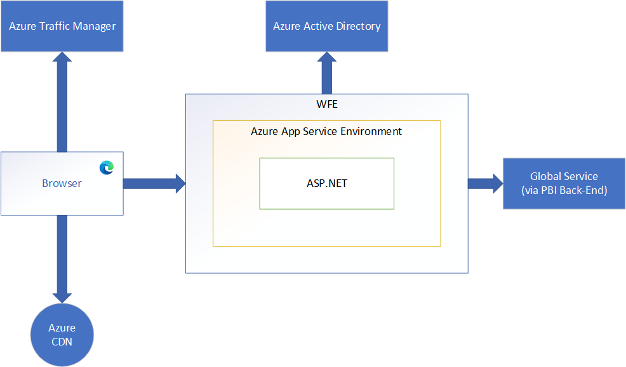

A WFE cluster consists of an ASP.NET website running in the [Azure App Service Environment](https://docs.microsoft.com/en-us/azure/app-service/environment/intro). When users attempt to connect to the Power BI service, the client's DNS service may communicate with the Azure Traffic Manager to find the most appropriate (usually nearest) datacenter with a Power BI deployment. For more information about this process, see [Performance traffic-routing method for Azure Traffic Manager](https://docs.microsoft.com/en-us/azure/traffic-manager/traffic-manager-routing-methods#performance-traffic-routing-method).

The WFE cluster assigned to the user manages the login and authentication sequence (described later in this article) and obtains an Azure AD access token once authentication is successful. The ASP.NET component within the WFE cluster parses the token to determine which organization the user belongs to, and then consults the Power BI Global Service. The WFE specifies to the browser which back-end cluster houses the organization's tenant. Once a user is authenticated, subsequent client interactions for customer data occur with the back-end or Premium cluster directly, without the WFE being an intermediator for those requests.

Static resources such as *.js, *.css, and image files are mostly stored on Azure Content Delivery Network (CDN) and retrieved directly by the browser. Note that Sovereign Government cluster deployments are an exception to this rule, and for compliance reasons will omit the CDN and instead use a WFE cluster from a compliant region for hosting static content.

**Ans 6**

### File data sources

* Excel Workbook
* Text/CSV
* XML
* JSON
* Folder
* PDF

### Database data sources

* SQL Server database
* Access database
* SQL Server Analysis Services database
* Oracle database
* IBM Db2 database
* MySQL database
* PostgreSQL database

### Azure data sources

* Azure SQL Database
* Azure Synapse Analytics SQL
* Azure Analysis Services database

### Other data sources

* Web
* Microsoft Exchange
* Hadoop File (HDFS)
* Spark

**Ans 5**

|  |  |  |
| --- | --- | --- |
|  | Microsoft Excel | Power BI |
| Data Import | Data import from almost everywhere  By power query | Data import also possible from everywhere By power query |
| Data transformation | Excel can also transform the data but not as compare to power bi. | Power bi ranks higher any other visualization/ data transformation tool. |
| Modelling | Ability to work on simple and structured data.  MDX language | Ideal for building complex data models easily.  DAX language |
| Reporting | Simple and less attractive reports than power bi. | More beautiful ,personalized attractive and interactive reports. |
| Cost | Need to spend additional amount to procure and build dashboards | Desktop is free and use for personal use but also have pro account for publish and more visulization |